**COMP 3059 – Capstone Project I**

**Software Requirements Analysis and Design Assignment**

## Introduction

**Software Requirements:** Visual Studio Code, React & Redis, Express.js, Mongo/Cluster DB

We aim to create the project in Visual Studio Code, we aim to create our Front-End Design using React and use Redis for a safer system

## Purpose

The purpose of this Systems Requirements Specifications document is to provide the guidelines necessary to design and implement the application fulfills all the given requirements.

In case of the Pocket Meal Application, this document will contain enough information so that in the event team is not able to complete the application, a future team can use this document and only this document to create another version of the application that still fulfills the requirements.

This SRS will be entirely design independent, focusing majorly on the end requirements that the application has to achieve. Furthermore, this document can be used by clients and stakeholders as a representation of their requirements of the SRS will be in essence fulfilling the contract with the client.

## Scope

This SRS will cover the Pocket Meal application. This name is simply for developmental purpose and in no way reflects the marketable name for this application.

Pocket Meal will be an application to help feed the hungry no matter what time or place it is, the main motto of this application is that No Soul should Sleep Hungry. The users for this application are the general public and no particular targeted audience is in frame for this application.

Pocket Meal will provide questionnaire’s that will store and share important details with people who want to donate food or help others or the people in need.

Pocket Meal will use location of users to make sure that people do not have any difficulty for their donation process.

Pocket Meal will also use a messaging API that will enable conversation between users so that it will reduce the possibilities of any confusion or fraud.

The ultimate goal of this application is to help and serve people better and, in the process, also reduce the food wastage or at least give people a peace of mind so that they don’t have to worry about monetarily helping other people.

# System Overview

## Project Perspective

Pocket Meal is a well planned and thought about application by our stakeholder Vimal. An integrated database will ensure the storage and the retrieval of the user related information and the required questionnaire data. We cannot say that it will be the only application that does this but it will surely be a unique application that will engross the users more and more and learn about their donating pattern.

## System Context

The application will be used as an independent application that will determine various needs for the users. The application address society issues where one portion of society gets to eat 3 course meal while the other half often sleeps hungry, it also describes and tackles issues such as people are often scared of giving donations or helping people by thinking that their money will be used for stuff they don’t intend on giving on their money for, this application address 75% society issues that involves food or hungry.

## General Constraints

**Platform:**

* Must work on mobile phones and PCs (Mac or Windows)

**Designed:**

* **For Mobile Phones:** must have internet connection, browser supporting flash player
* **For PCs:** must have OS X or Windows 7 and above

**Tested:**

* Across multiple systems that will have valid requirements
* For various bugs that can be fixed so they are not met when the application is up and running

## Assumptions and Dependencies

* Application will be used by multiple people and they all are willing to either help or need food
* They are within the range of 5 KMs
* They are willing to travel at least 1 KM
* They have access to internet

## 3.0 Functional Requirements

### 

### 3.1 <Functional Requirement or Feature #1>

* Register – The user must be able to register once in order to get access to the application.
* Login – A registered user has to enter his/her username and password in order to access the application.
* Walkthrough – An option available for the first-time users where it will show tips on how to use the application.
* Questionnaire – This will be the main part of this application as the users from both sides will fill out questionnaire to depict the food item they have, the amount of food they willing to donate or need (includes type), the amount of distance they are willing to travel.
* Setting – This option will enable the users to modify the setting for their username, profile picture or password.
* Logout – This will enable the users to logout of the application
* Messaging – This feature will enable the users to text the donor or people in need for their location and necessary details.
* Send/Receive Photos – This will be an important part of the application as it will help in identification process for either user.

...

## 

## 3.2 Use Cases

### 3.2.1 Use Case #1 ...

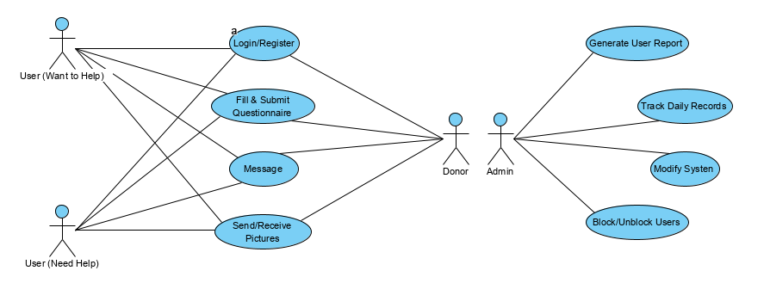

**3.3 Data Modelling and Analysis**

**Normalized Data Model Diagram**

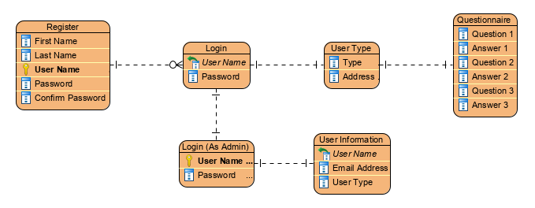

**Activity Diagrams**

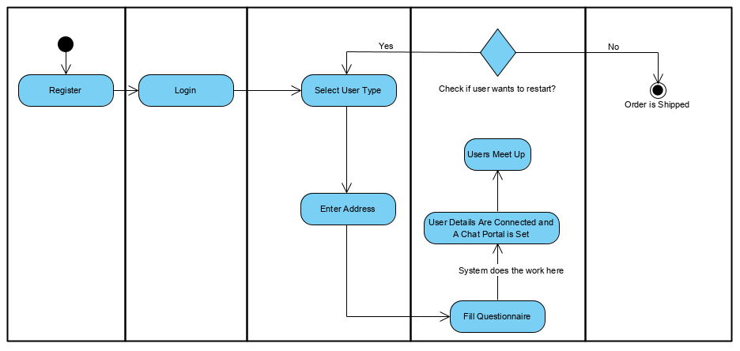

**Sequence Diagrams**

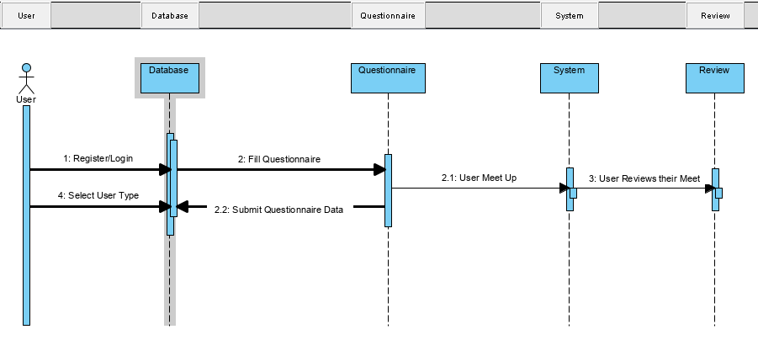

**UML Class Diagram**

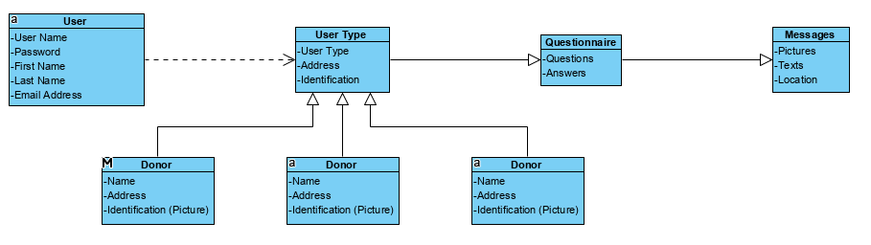

## 3.4 Process Modelling

**Data Flow Diagram**

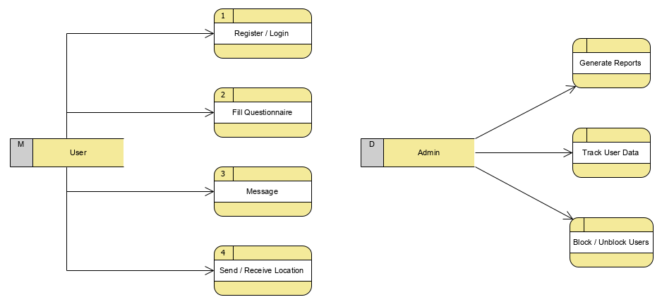

# 4.0 Non-Functional Requirements

* We will be using Redux and Redis in addition to React Framework that will make the database more secure.
* We also aim to use Mongo/Cluster DB to store information.
* We are using Node.js & Express.js to quicken the work and make it more reliable and flexible.
* We are also using Google Maps API for location.

## 5.0 Logical Database Requirements

Yes, a database will be used to store the following information:

* Login Details for users (Username, Email Address, Password)
* Questionnaire Information (FILLED)
* Food Type

The data formats are as followed:

* Login/Registration information is varchar for basic information such as:
* First Name, Last Name, User Name
* Email, Password

## Questionnaire:

* Questions, Answers – Varchar

## 6.0 Other Requirements

No Additional Requirements.

**7.0 Approval**

|  |  |  |  |
| --- | --- | --- | --- |
| Project Role | Name | Signature | Date |
|  |  |  |  |
|  |  |  |  |
|  |  |  |  |